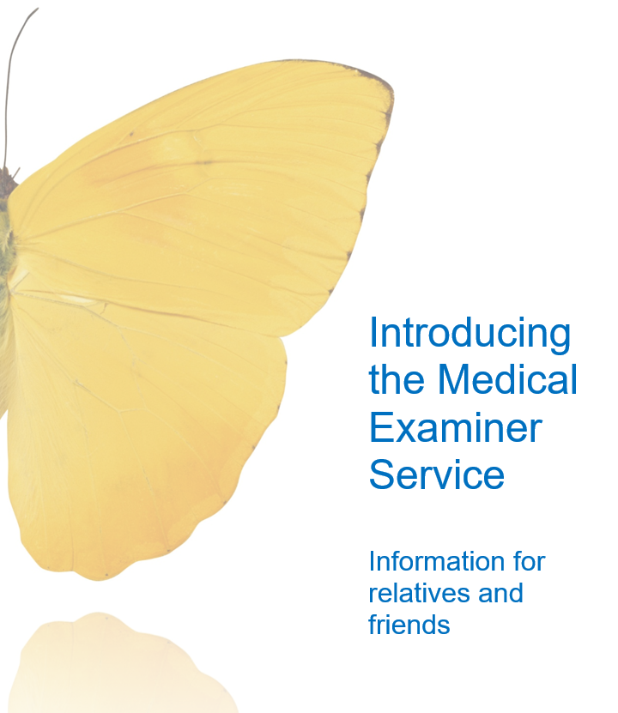

***Please accept our deepest condolences following the death of your relative or friend.***

The Medical Examiner service was rolled out across the NHS in England from 2019 with the aim of improving death certification and ensuring that bereaved families and friends are kept at the centre of the process. By introducing this new service, the NHS aims to provide an opportunity for the bereaved to ask questions about the cause of death and discuss the care that their friend or relative received.

**Who are Medical Examiners and Medical Examiner Officers?**

Medical Examiners (MEs) are senior NHS Doctors who have not been involved in the care of the person who died. Medical Examiner Officers are the clinical support for the MEs. They have all had specialist training to undertake the roles and help families during these difficult times, knowing the bereaved will need support.

**What does the Medical Examiner do?**

MEs and MEOs review the relevant medical records and discuss the care with the medical team who were looking after the person who died. This is to ensure that when completing the Medical Certificate of Cause of Death (MCCD), the document accurately reflects the details of the cause of death. Medical Examiners or their team (MEOs) will discuss the cause of death with the bereaved family or close friends. This gives you the opportunity to ask questions, give any feedback or raise concerns, if you have any, in relation to your loved one’s death. You will receive a telephone call a few days after the death. The ME can make it easier for you to understand some of the medical language in the MCCD or the patient’s records. In some situations, the death is discussed with the Coroner’s Office. By law, some deaths must be reported and then investigated by the coroner. The ME office are guided by the coroner’s decisions, but that may mean they cannot issue the MCCD. The ME Office will be able to support you if Coroner involvement is required

**Working with GP and GP practices:**

MEs work closely with GPs to ensure an accurate cause of death is recorded on the MCCD. GPs and their staff have worked closely with the ME service to streamline the process to be as efficient as possible so not to introduce any unnecessary delays. The GP will still be responsible for the issue of the MCCD and any funeral paperwork that is required.

**What is the Coroner’s Service?**

The coroner’s service investigates deaths where, for whatever reason, a doctor cannot issue a Medical Certificate of Cause of Death.

Some deaths by law must be notified to the coroner - you can read about this on the internet:

[**https://www.gov.uk/government/publications/notification-of-deaths-regulations-2019-guidance**](https://www.gov.uk/government/publications/notification-of-deaths-regulations-2019-guidance)

The coroner’s investigation is independent from the Medical Examiner, although they may still provide expert medical advice to the coroner. Some deaths must be reported to the coroner. You can read more information on the Manchester South Coroner’s Service website:

[**http://www.coronersmanchestersouth.org.uk/**](https://gbr01.safelinks.protection.outlook.com/?url=http%3A%2F%2Fwww.coronersmanchestersouth.org.uk%2F&data=05%7C01%7Cs.wesley2%40nhs.net%7Cc50079a9b18c4a81199808db2543946f%7C37c354b285b047f5b22207b48d774ee3%7C0%7C0%7C638144744393817600%7CUnknown%7CTWFpbGZsb3d8eyJWIjoiMC4wLjAwMDAiLCJQIjoiV2luMzIiLCJBTiI6Ik1haWwiLCJXVCI6Mn0%3D%7C3000%7C%7C%7C&sdata=mc2ljhl23EXnGy1QgD1v646SZ%2BCW2%2FFZ0gUR4vztB1M%3D&reserved=0)

**Why am I being asked to speak to the Medical Examiner?**

A discussion with the Medical Examiner or their team will provide you with an opportunity to have an open and honest conversation with someone who was not involved in providing care to your loved one who has died. It could be as simple as helping you to understand more about the treatment and causes of death or to understand the medical language used. There may be some aspect about their care which you would like to discuss, and this is your opportunity to have a conversation about your thoughts and feelings. If the Medical Examiners find any issues with care that need further inquiry, they will refer these cases to someone who can arrange this. As well as answering your questions, this can help the NHS provide better care for other patients and carers in the future. It may provide ways in which patient and family care could be improved.

**Can I ask the Medical Examiner to talk to someone else if it is too difficult for me to speak with them?**

Yes, this can be discussed when the ME’s team contact you, or you can let the GP surgery know if you would rather they spoke to someone else on your behalf. The GP surgery will provide the agreed contact details to the Medical Examiner’s team

If you change your mind and feel able to talk to the team about the death of your relative or friend, you can let the team know at any point.

**What questions will I be asked?**

The Medical Examiner or their staff are able to explain what is written on the Medical Certificate of Cause of Death and why, if requested. They will also discuss the Medical Examiner’s review and ask if there are any concerns or questions about the care the person received before their death. This is the best time for you to ask any questions you have about the death and to speak about anything that concerns you.

**What happens if I do not want to speak to the Medical Examiner or their team?**

We understand this is likely to be a difficult time for you. Speaking to someone is completely your choice.

If you are not sure, you can contact the Medical Examiner or a member of their team on **0161 419 5773** and ask for more information before deciding if you want to go ahead.

If would prefer to opt out of any discussions with the Medical Examiner team, please advise and your contact information will be deleted. Opting out of discussions with the Medical Examiner Team will not affect any support you will receive from the surgery.

The Medical Examiner Office is open for calls between 9:00am and 4:30pm Monday – Friday.

**What will happen if something was not right?**

The Medical Examiner and their staff are here to listen to your questions and concerns and provide answers if possible. If issues are found, they will be passed onto the appropriate people to be investigated; if this is the case the Medical Examiner or Officer can explain this process to you. Medical Examiners do not undertake formal investigations.

**Will this mean funeral plans or release of the body take longer?**

Medical Examiners make every effort to avoid any delays and work with families and friends of the deceased to allow registering of deaths. Medical Examiners and their team will try to be flexible, especially where relatives need access to the deceased, or release of the deceased quickly for cultural or religious reasons.

**What can I do if I have questions or concerns about the Medical Examiner process?**

If you are unhappy with the Medical Examiner’s advice, we recommend that you discuss this with staff from the Medical Examiner’s office at first.

**Contact information**

You can contact the Medical Examiner office by telephone or email:

0161 419 5773 or via [Medicalexaminers.office@stockport.nhs.uk](mailto:Medicalexaminers.office@stockport.nhs.uk)

|  |  |  |  |
| --- | --- | --- | --- |
|  |  |  |  |